AWS VPC and EC2 Setup Documentation

1. Introduction
This document explains the basic steps to create an AWS VPC, configure public and private subnets, and launch EC2 instances with required networking components.

2. Services Used
- Amazon VPC
- Subnets
- Internet Gateway
- NAT Gateway
- Route Tables
- EC2
- Security Groups

3. VPC Architecture
VPC (10.0.0.0/16)
|
|-- Public Subnet (10.0.1.0/24)
| |-- Internet Gateway
| |-- NAT Gateway
| |-- Public EC2
|
|-- Private Subnet (10.0.2.0/24)
|-- Private EC2

4. VPC Configuration
4.1 Create VPC
- Name: my-first-vpc
- CIDR: 10.0.0.0/16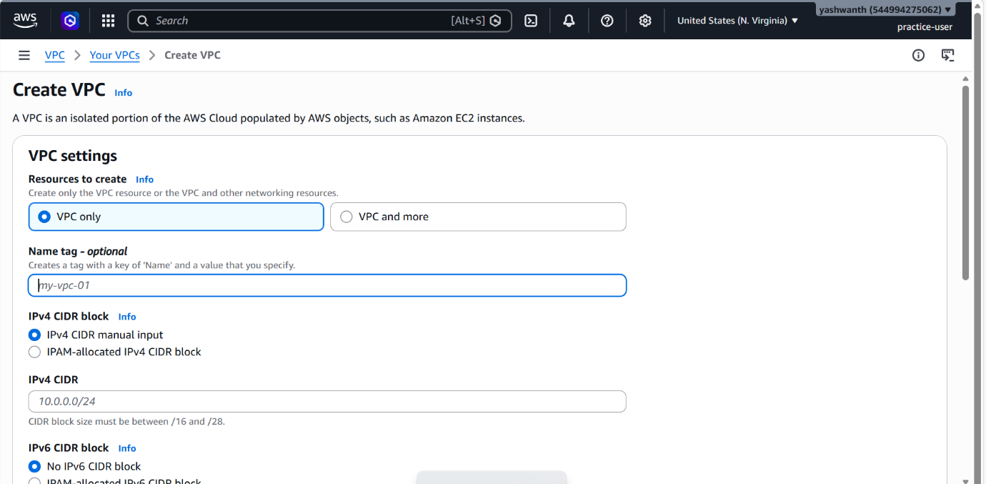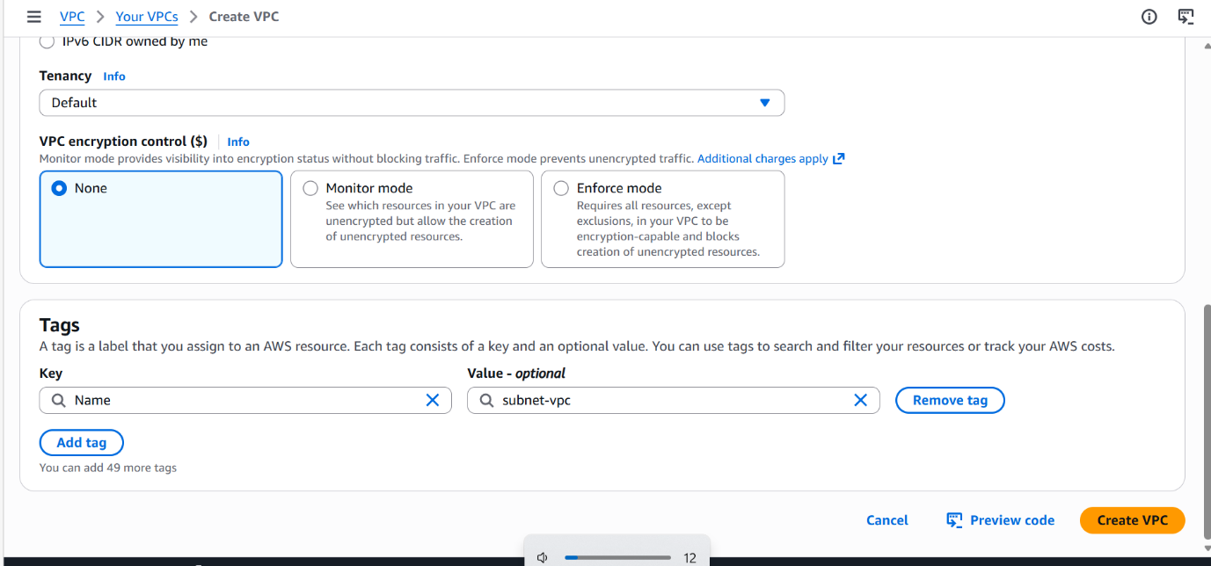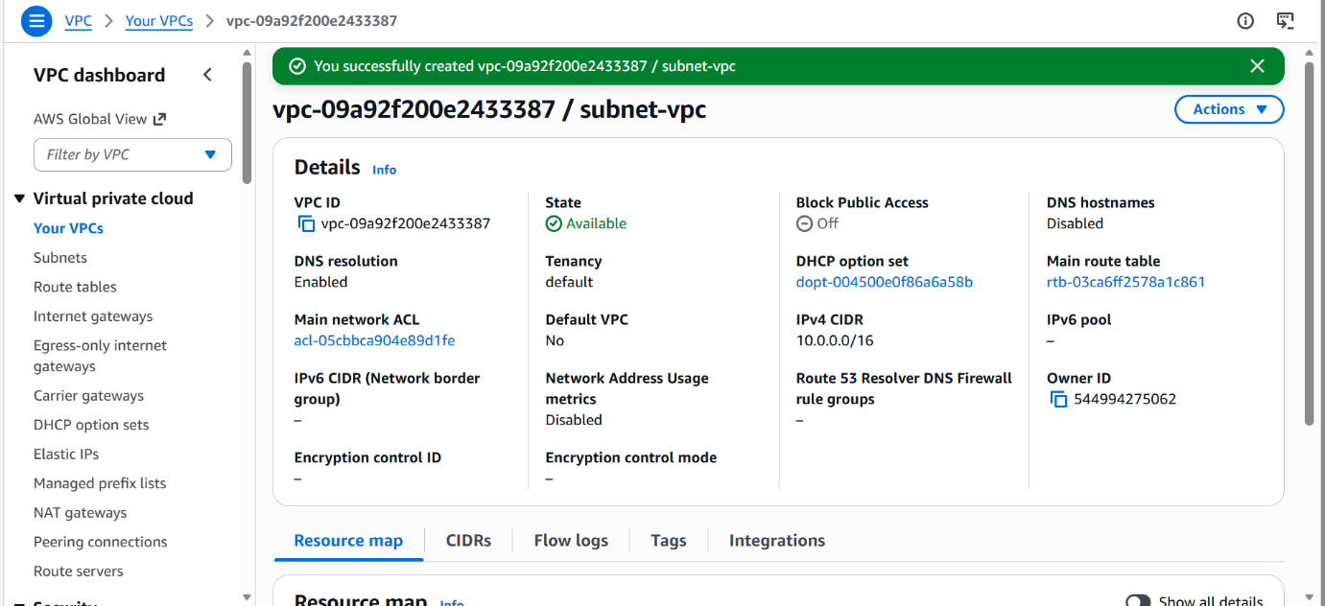
4.2 Create Subnets
- Public Subnet: 10.0.1.0/24
- Private Subnet: 10.0.2.0/24
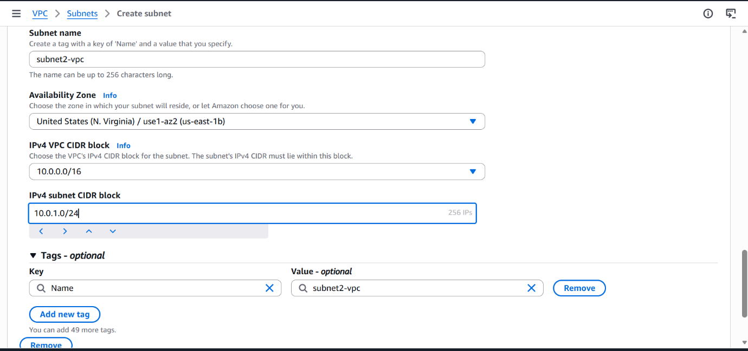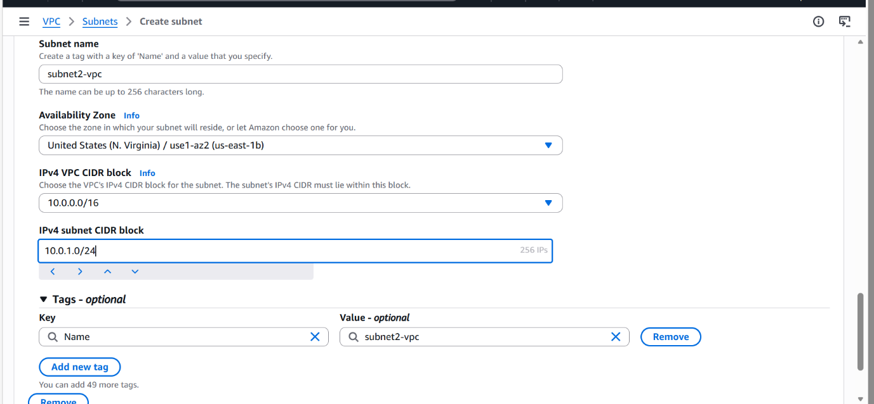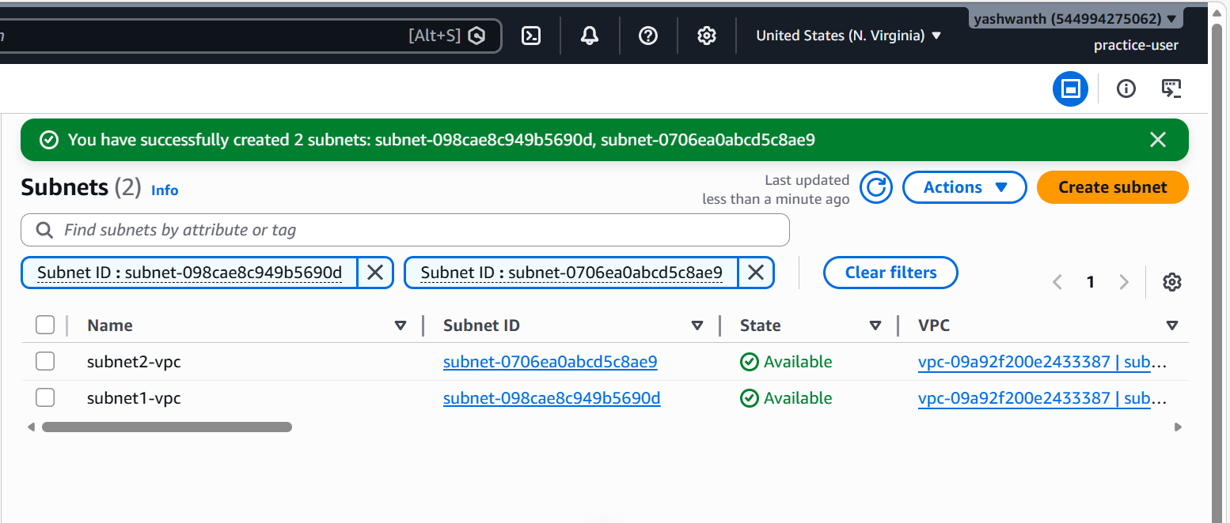

5. Internet and Routing
Internet Gateway
- Create and attach to VPC
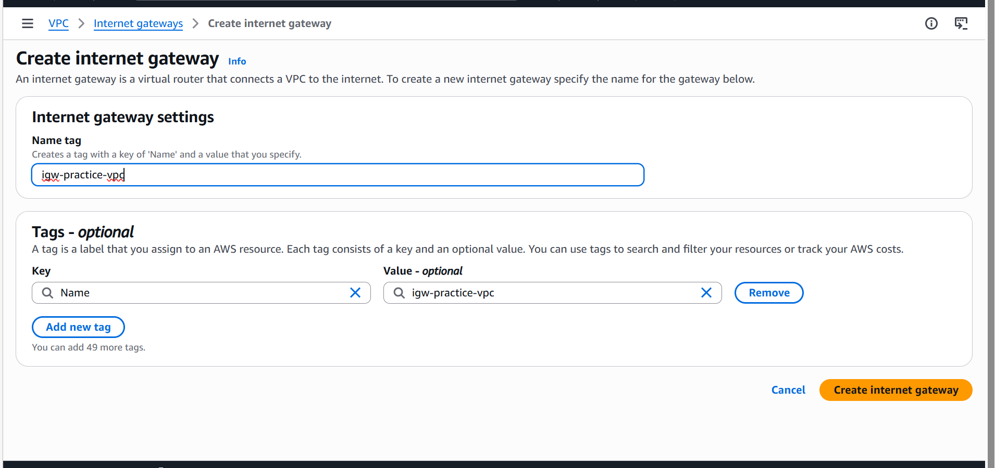

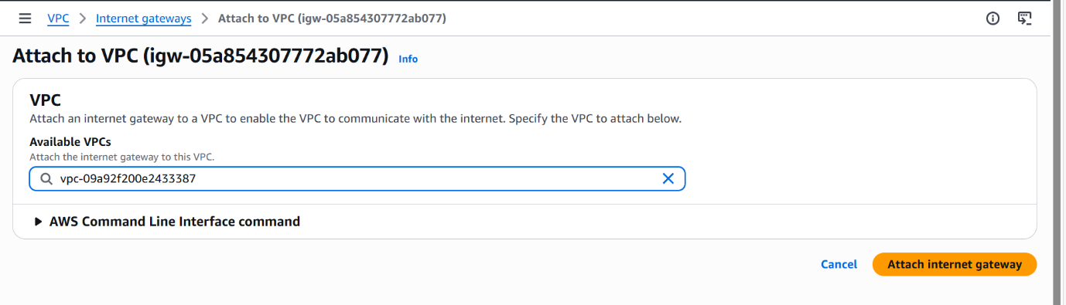
Route Tables
Public Route Table
- Route: 0.0.0.0/0 → Internet Gateway
- Associate with public subnet
Private Route Table
- Route: 0.0.0.0/0 → NAT Gateway
- Associate with private subnet
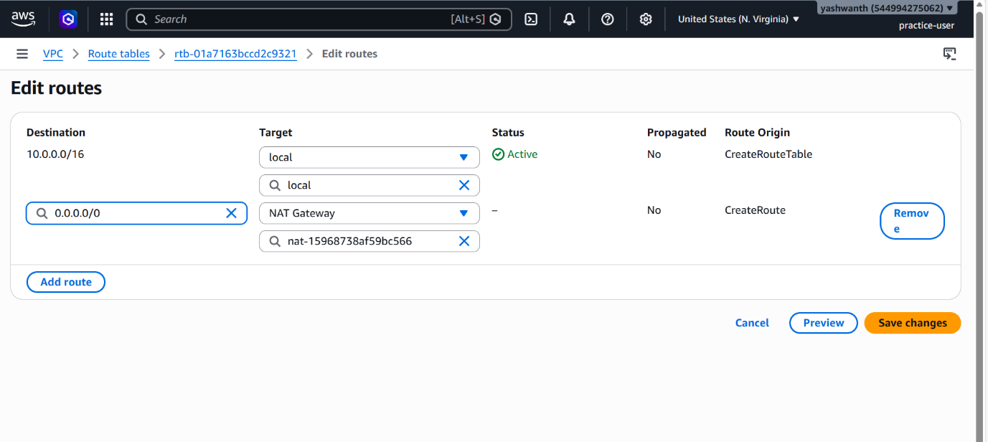
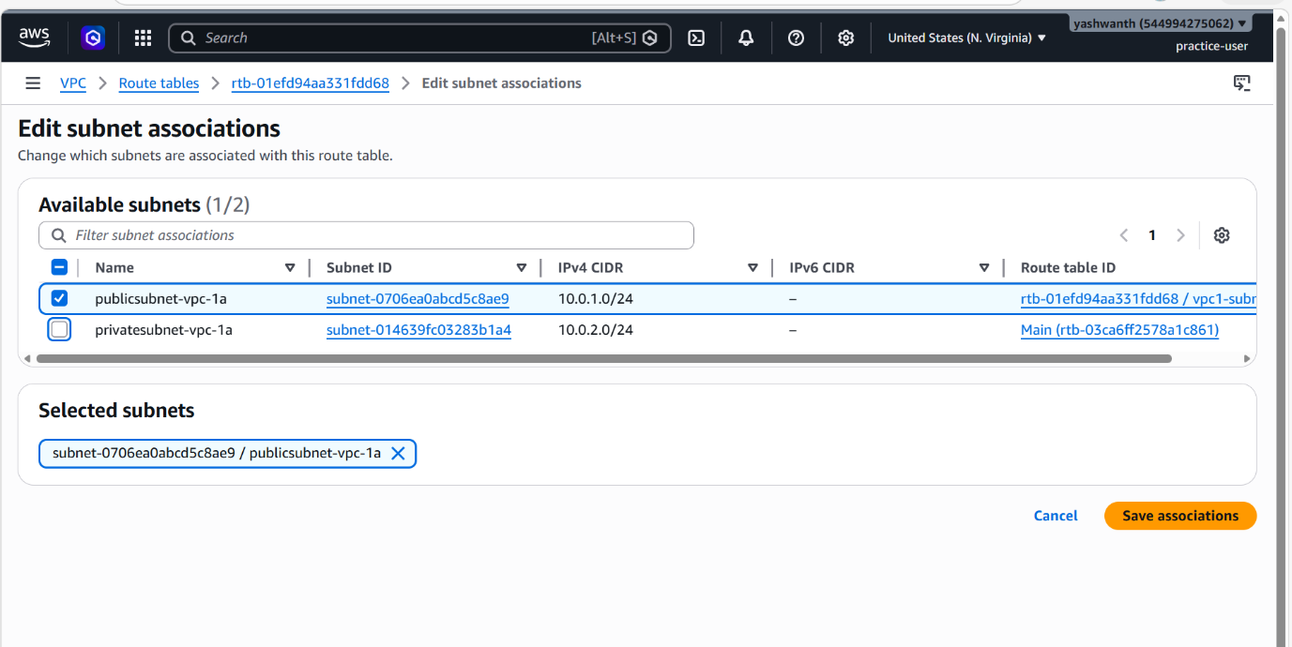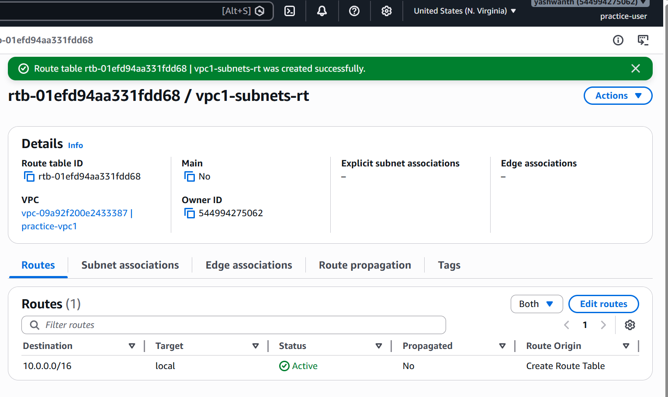

6. NAT Gateway
- Created in public subnet
- Used to provide internet access to private subnet
- Uses an Elastic IP
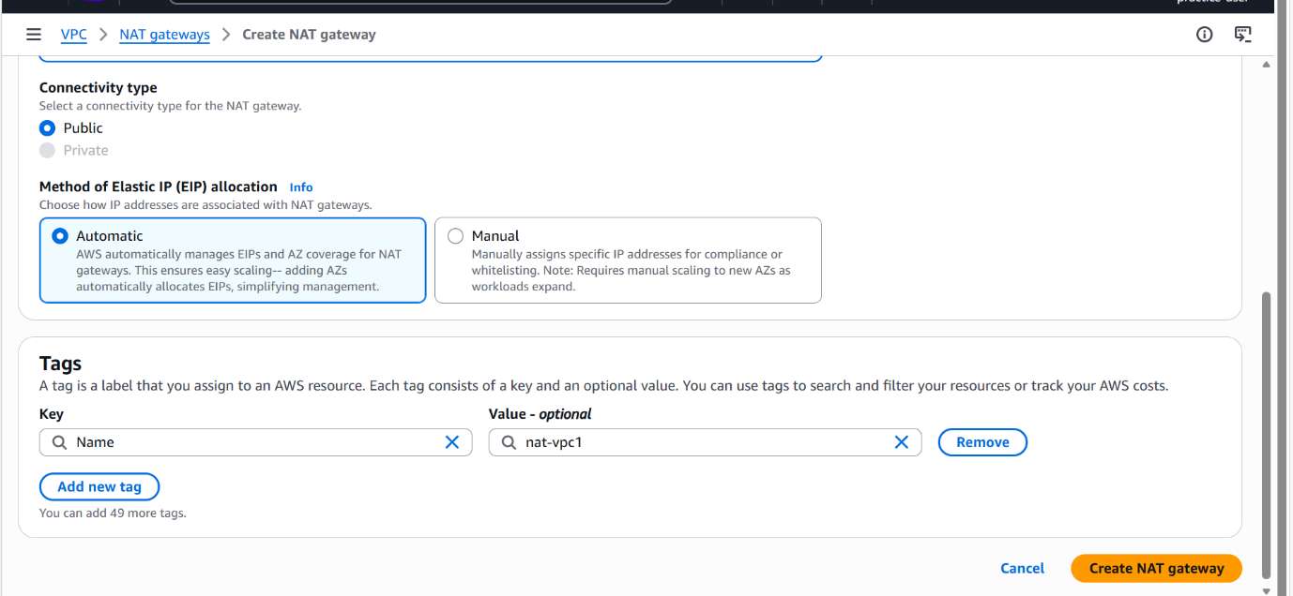

7. EC2 Deployment
Public EC2
- Subnet: Public Subnet
- Public IP: Enabled
- Use case: Web server / Bastion host
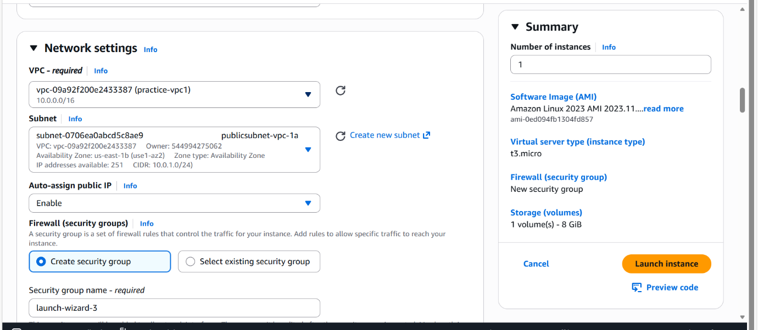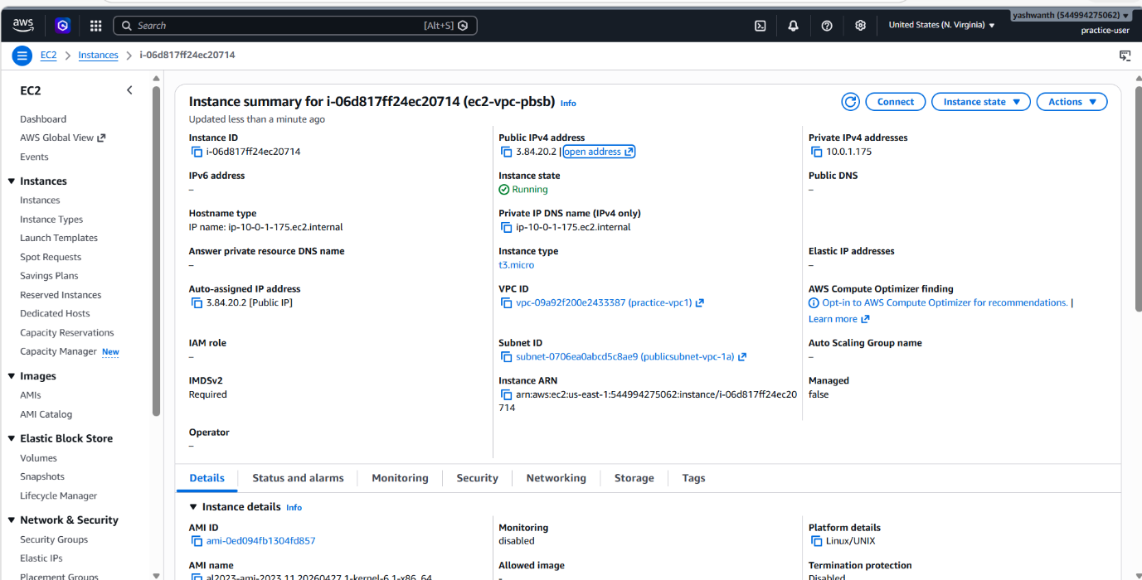

8. User Data Scripts
Public EC2 – Apache Web Server
#!/bin/bash
yum update -y
yum install -y httpd
systemctl start httpd
systemctl enable httpd
echo "<h1>Public EC2 Running</h1>" > /var/www/html/index.html

9. Conclusion
This setup creates a secure and scalable VPC with public and private subnets, controlled internet access, and EC2 instances configured using user data.

